GPSS World Simulation Report - Untitled Model 1.41.1

Thursday, November 08, 2018 00:00:49

START TIME END TIME BLOCKS FACILITIES STORAGES

0.000 6783.970 43 1 0

NAME VALUE

BUS 10016.000

CLIENTS 10005.000

CONTIN 8.000

COUNTER 10011.000

CP 10002.000

CP_TIME 10009.000

DELIVERY_TIME 10014.000

FUNC_VALUE_MESSAGE 10003.000

MCOUNTER 10006.000

MESSAGES 10000.000

PARAM2 23.000

PROG 24.000

QBUS 10015.000

RAND 10004.000

RECEIVER 10013.000

SENDER 10012.000

SET_RECEIVER_NUMBER 15.000

SET_SENDER_NUMBER 9.000

TYPE 10008.000

TYPES 10001.000

VAL 10010.000

LABEL LOC BLOCK TYPE ENTRY COUNT CURRENT COUNT RETRY

1 GENERATE 339 0 0

2 SPLIT 339 0 0

3 ASSIGN 1001 0 0

4 ASSIGN 1001 0 0

5 ASSIGN 1001 0 0

6 TEST 1001 0 0

7 TERMINATE 0 0 0

CONTIN 8 ASSIGN 1001 0 0

SET_SENDER_NUMBER 9 ASSIGN 1021 0 0

10 ASSIGN 1021 0 0

11 TEST 1021 0 0

12 MSAVEVALUE 1001 0 0

13 SAVEVALUE 1001 0 0

14 ASSIGN 1001 0 0

SET_RECEIVER_NUMBER 15 ASSIGN 1036 0 0

16 ASSIGN 1036 0 0

17 TEST 1036 0 0

18 MSAVEVALUE 1001 0 0

19 SAVEVALUE 1001 0 0

20 TEST 1001 0 0

21 ASSIGN 485 0 0

22 TRANSFER 485 0 0

PARAM2 23 ASSIGN 516 0 0

PROG 24 QUEUE 1001 0 0

25 SEIZE 1001 0 0

26 DEPART 1001 0 0

27 ADVANCE 1001 0 0

28 RELEASE 1001 0 0

29 MSAVEVALUE 1001 0 0

30 SAVEVALUE 1001 0 0

31 ADVANCE 1001 0 0

32 TEST 1001 0 0

33 MSAVEVALUE 1001 0 0

34 SAVEVALUE 1001 0 0

35 QUEUE 1001 0 0

36 SEIZE 1001 1 0

37 DEPART 1000 0 0

38 ADVANCE 1000 0 0

39 RELEASE 1000 0 0

40 MSAVEVALUE 1000 0 0

41 MSAVEVALUE 1000 0 0

42 SAVEVALUE 1000 0 0

43 TERMINATE 1000 0 0

FACILITY ENTRIES UTIL. AVE. TIME AVAIL. OWNER PEND INTER RETRY DELAY

BUS 2002 0.291 0.985 1 1002 0 0 0 0

QUEUE MAX CONT. ENTRY ENTRY(0) AVE.CONT. AVE.TIME AVE.(-0) RETRY

QBUS 3 1 2002 502 0.344 1.166 1.556 0

SAVEVALUE RETRY VALUE

MCOUNTER 0 98.000

CEC XN PRI M1 ASSEM CURRENT NEXT PARAMETER VALUE

1002 0 6780.000 997 36 37

SENDER 71.000

CP_TIME 1.000

DELIVERY_TIME 1.050

VAL 0.100

RECEIVER 21.000

COUNTER 1.000

TYPE 2.000

FEC XN PRI BDT ASSEM CURRENT NEXT PARAMETER VALUE

1000 0 6800.000 1000 0 1

Messages FUNCTION RN1,C2

0,1/1,4

Types FUNCTION RN2,D3

.33,1/.66,2/1,3

CP FUNCTION P$Type,D3

1,1/2,1/3,1

FUNC_Value_message FUNCTION P$Type,D3

1,.01/2,.1/3,.2

Rand FUNCTION RN3,C2

0,1/1,101

Clients MATRIX ,1,100

INITIAL X$MCounter,100

GENERATE 20

SPLIT FN$Messages

ASSIGN Type,FN$Types

ASSIGN CP_time,FN$CP

ASSIGN Val,FN$FUNC_Value_message

TEST L X$MCounter,2,Contin

TERMINATE

Contin ASSIGN counter,0

Set_sender_number ASSIGN counter+,1

RMULT ,P$counter

ASSIGN Sender,(FN$Rand\1)

Test E MX$Clients(1,P$Sender),0,Set_sender_number

MSAVEVALUE Clients,1,P$Sender,1

SAVEVALUE MCounter-,1

ASSIGN counter,0

Set_receiver_number ASSIGN counter+,1

RMULT ,P$counter

ASSIGN Receiver,(FN$Rand\1)

Test E MX$Clients(1,P$Receiver),0,Set_receiver_number

MSAVEVALUE Clients,1,P$Receiver,1

SAVEVALUE MCounter-,1

TEST G P$Sender,P$Receiver,Param2

ASSIGN Delivery_time,((P$Sender-P$Receiver)#0.005+P$Val#8)

TRANSFER ,Prog

Param2 ASSIGN Delivery_time,((P$Receiver-P$Sender)#0.005+P$Val#8)

Prog QUEUE QBUS

SEIZE BUS

DEPART QBUS

ADVANCE P$Delivery_time

RELEASE BUS

MSAVEVALUE Clients,1,P$Sender,0

SAVEVALUE MCounter+,1

ADVANCE P$CP_time

Test E MX$Clients(1,P$Sender),0

MSAVEVALUE Clients,1,P$Sender,1

SAVEVALUE MCounter-,1

QUEUE QBUS

SEIZE BUS

DEPART QBUS

ADVANCE P$Delivery_time

RELEASE BUS

MSAVEVALUE Clients,1,P$Receiver,0

MSAVEVALUE Clients,1,P$Sender,0

SAVEVALUE MCounter+,2

TERMINATE 1

START 1000

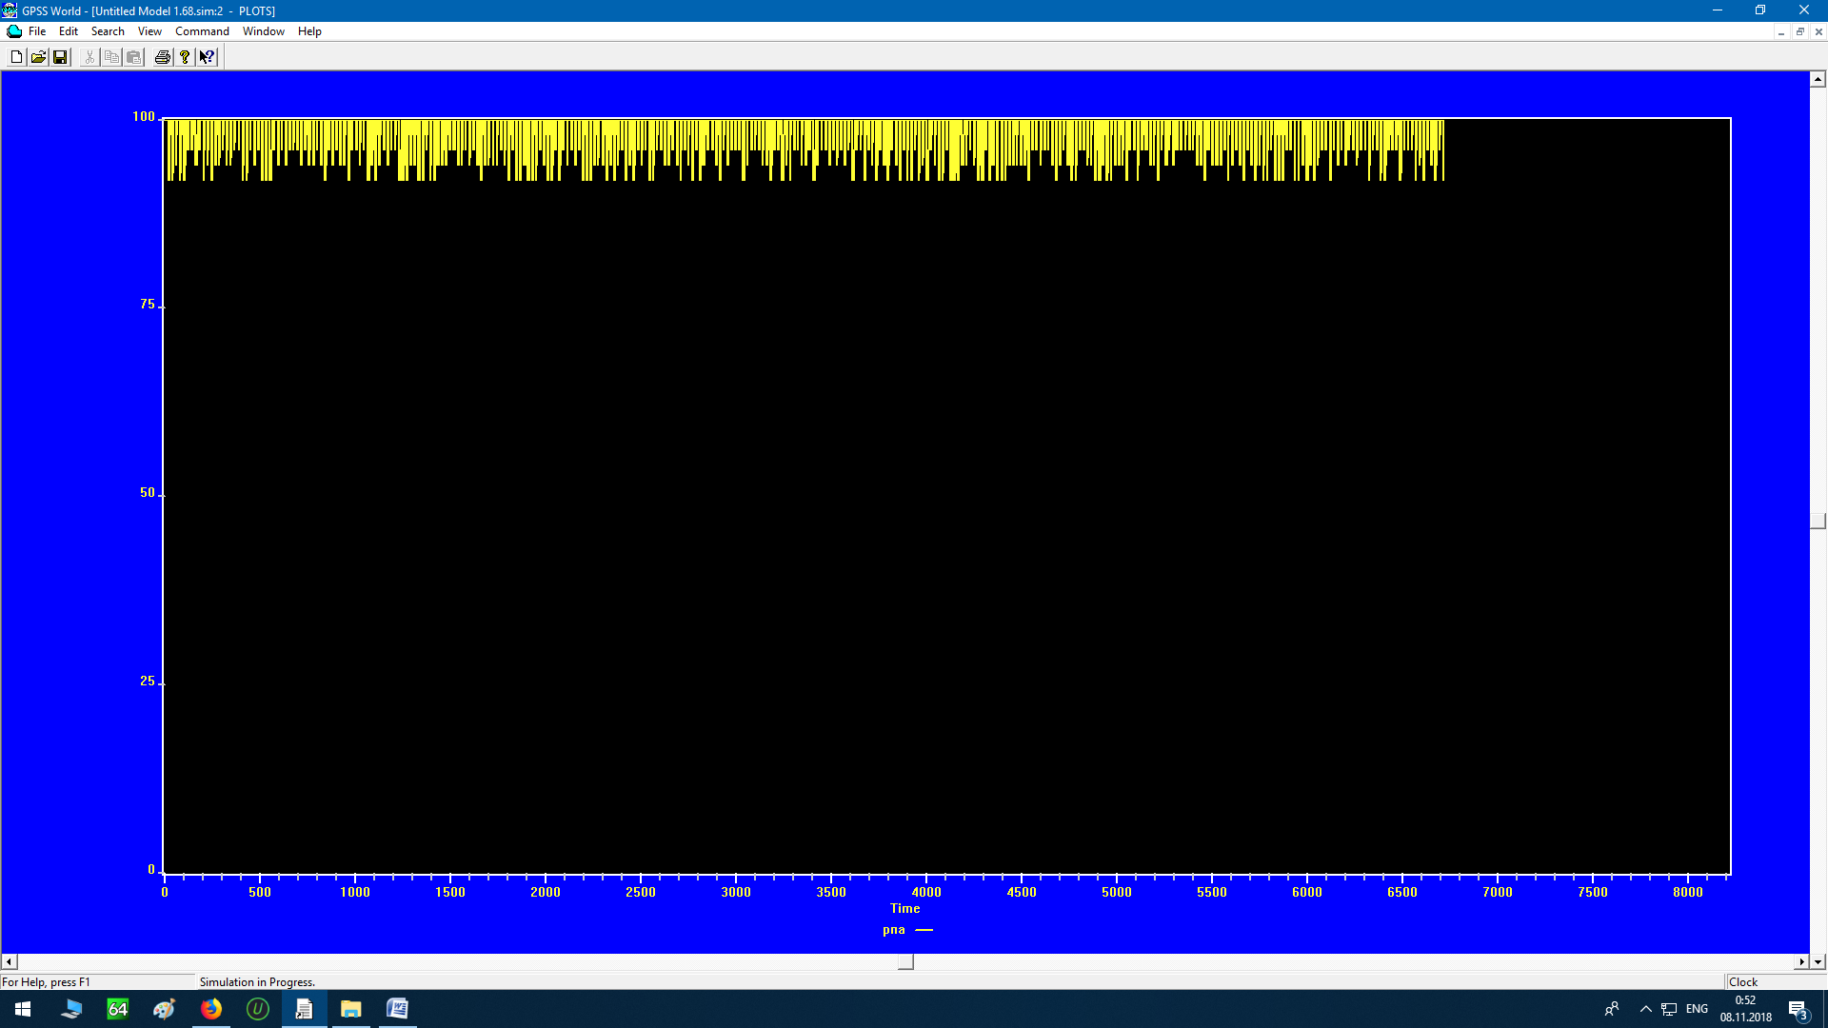

Messages FUNCTION RN1,C2

0,1/1,4

Types FUNCTION RN2,D3

.33,1/.66,2/1,3

CP FUNCTION P$Type,D3

1,2/2,1/3,.5

FUNC_Value_message FUNCTION P$Type,D3

1,.1/2,.1/3,2

Rand FUNCTION RN3,C2

0,1/1,101

Clients MATRIX ,1,100

INITIAL X$MCounter,100

GENERATE 20

SPLIT FN$Messages

ASSIGN Type,FN$Types

ASSIGN CP_time,FN$CP

ASSIGN Val,FN$FUNC_Value_message

TEST L X$MCounter,2,Contin

TERMINATE

Contin ASSIGN counter,0

Set_sender_number ASSIGN counter+,1

RMULT ,P$counter

ASSIGN Sender,(FN$Rand\1)

Test E MX$Clients(1,P$Sender),0,Set_sender_number

MSAVEVALUE Clients,1,P$Sender,1

SAVEVALUE MCounter-,1

ASSIGN counter,0

Set_receiver_number ASSIGN counter+,1

RMULT ,P$counter

ASSIGN Receiver,(FN$Rand\1)

Test E MX$Clients(1,P$Receiver),0,Set_receiver_number

MSAVEVALUE Clients,1,P$Receiver,1

SAVEVALUE MCounter-,1

TEST G P$Sender,P$Receiver,Param2

ASSIGN Delivery_time,((P$Sender-P$Receiver)#0.005+P$Val#8)

TRANSFER ,Prog

Param2 ASSIGN Delivery_time,((P$Receiver-P$Sender)#0.005+P$Val#8)

Prog QUEUE QBUS

SEIZE BUS

DEPART QBUS

ADVANCE P$Delivery_time

RELEASE BUS

MSAVEVALUE Clients,1,P$Sender,0

SAVEVALUE MCounter+,1

ADVANCE P$CP_time

Test E MX$Clients(1,P$Sender),0

MSAVEVALUE Clients,1,P$Sender,1

SAVEVALUE MCounter-,1

QUEUE QBUS

SEIZE BUS

DEPART QBUS

ADVANCE P$Delivery_time

RELEASE BUS

MSAVEVALUE Clients,1,P$Receiver,0

MSAVEVALUE Clients,1,P$Sender,0

SAVEVALUE MCounter+,2

TERMINATE 1

START 1000

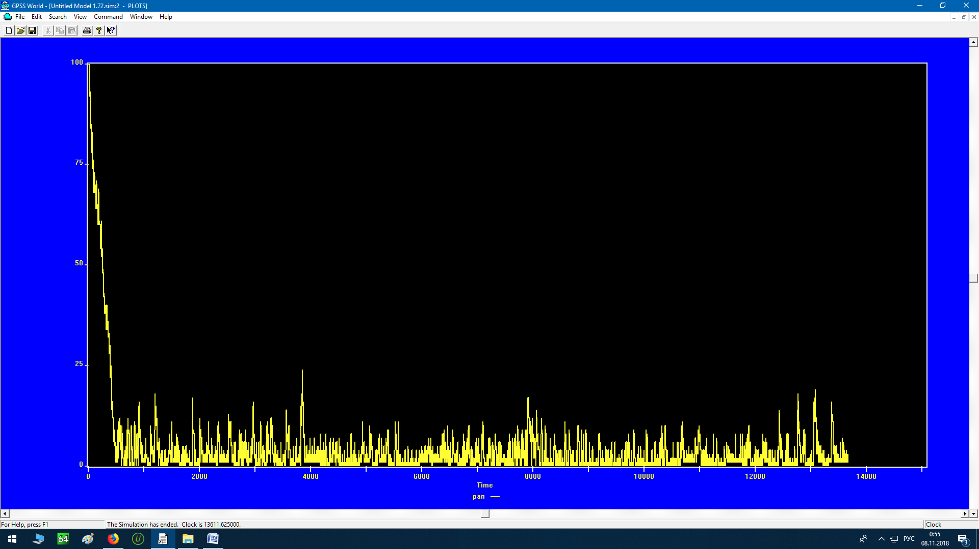

GPSS World Simulation Report - Untitled Model 1.73.1

Thursday, November 08, 2018 00:56:34

START TIME END TIME BLOCKS FACILITIES STORAGES

0.000 13611.625 43 1 0

NAME VALUE

BUS 10016.000

CLIENTS 10005.000

CONTIN 8.000

COUNTER 10011.000

CP 10002.000

CP_TIME 10009.000

DELIVERY_TIME 10014.000

FUNC_VALUE_MESSAGE 10003.000

MCOUNTER 10006.000

MESSAGES 10000.000

PARAM2 23.000

PROG 24.000

QBUS 10015.000

RAND 10004.000

RECEIVER 10013.000

SENDER 10012.000

SET_RECEIVER_NUMBER 15.000

SET_SENDER_NUMBER 9.000

TYPE 10008.000

TYPES 10001.000

VAL 10010.000

LABEL LOC BLOCK TYPE ENTRY COUNT CURRENT COUNT RETRY

1 GENERATE 680 0 0

2 SPLIT 680 0 0

3 ASSIGN 2016 0 0

4 ASSIGN 2016 0 0

5 ASSIGN 2016 0 0

6 TEST 2016 0 0

7 TERMINATE 966 0 0

CONTIN 8 ASSIGN 1050 0 0

SET_SENDER_NUMBER 9 ASSIGN 26863 0 0

10 ASSIGN 26863 0 0

11 TEST 26863 0 0

12 MSAVEVALUE 1050 0 0

13 SAVEVALUE 1050 0 0

14 ASSIGN 1050 0 0

SET_RECEIVER_NUMBER 15 ASSIGN 43669 0 0

16 ASSIGN 43669 0 0

17 TEST 43669 0 0

18 MSAVEVALUE 1050 0 0

19 SAVEVALUE 1050 0 0

20 TEST 1050 0 0

21 ASSIGN 526 0 0

22 TRANSFER 526 0 0

PARAM2 23 ASSIGN 524 0 0

PROG 24 QUEUE 1050 21 0

25 SEIZE 1029 0 0

26 DEPART 1029 0 0

27 ADVANCE 1029 0 0

28 RELEASE 1029 0 0

29 MSAVEVALUE 1029 0 0

30 SAVEVALUE 1029 0 0

31 ADVANCE 1029 3 0

32 TEST 1026 0 0

33 MSAVEVALUE 1026 0 0

34 SAVEVALUE 1026 0 0

35 QUEUE 1026 25 0

36 SEIZE 1001 1 0

37 DEPART 1000 0 0

38 ADVANCE 1000 0 0

39 RELEASE 1000 0 0

40 MSAVEVALUE 1000 0 0

41 MSAVEVALUE 1000 0 0

42 SAVEVALUE 1000 0 0

43 TERMINATE 1000 0 0

FACILITY ENTRIES UTIL. AVE. TIME AVAIL. OWNER PEND INTER RETRY DELAY

BUS 2030 0.999 6.695 1 1893 0 0 0 46

QUEUE MAX CONT. ENTRY ENTRY(0) AVE.CONT. AVE.TIME AVE.(-0) RETRY

QBUS 49 47 2076 1 45.844 300.583 300.728 0

SAVEVALUE RETRY VALUE

MCOUNTER 0 3.000

CEC XN PRI M1 ASSEM CURRENT NEXT PARAMETER VALUE

1893 0 12720.000 1888 36 37

SENDER 68.000

CP_TIME 2.000

DELIVERY_TIME 0.995

VAL 0.100

RECEIVER 29.000

COUNTER 8.000

TYPE 1.000

1908 0 12840.000 1905 31 32

SENDER 87.000

CP_TIME 1.000

DELIVERY_TIME 0.945

VAL 0.100

RECEIVER 58.000

COUNTER 42.000

TYPE 2.000

1920 0 12940.000 1920 31 32

SENDER 85.000

CP_TIME 2.000

DELIVERY_TIME 0.820

VAL 0.100

RECEIVER 89.000

COUNTER 87.000

TYPE 1.000

1928 0 13000.000 1928 31 32

SENDER 68.000

CP_TIME 2.000

DELIVERY_TIME 0.860

VAL 0.100

RECEIVER 80.000

COUNTER 14.000

TYPE 1.000

FEC XN PRI BDT ASSEM CURRENT NEXT PARAMETER VALUE

2014 0 13620.000 2014 0 1